Pastor Joshua Brunette Bible Prophecy: Trapped Part I Ponca City Assembly 9.13.2026
Opening: The Bible tells us of a time in the near future when the inhabitants of our world will be caught unaware in a trap set by our enemy Satan. For the Church we are also warned and encouraged to know the times and seasons in which we live. The Bible is not silent on what the world will look like just before Jesus comes for His church and the tribulation hour begins. This message series is designed to expose the trap that is being set by our adversary for an unsuspecting world, do not let it be you.
- Why preach on Bible Prophecy?
  - Luke 21:34-36 34But watch yourselves, or your hearts will be weighed down by dissipation, (overindulgence, squandering money, energy and resources) drunkenness, and the worries of life—and that day will spring upon you suddenly like a snare. 35For it will come upon all who dwell on the face of all the earth. 36So keep watch at all times, and pray that you may have the strength to escape all that is about to happen and to stand before the Son of Man.”
  - Jesus Christ preached on the final things and warned us many times in His ministry of the last days events. Jesus Himself told us to be prepared and to prepare others so they would not be caught off guard.

- In the last of the last days things will become Dangerous
  - 2nd Timothy 3:1 – 17 3 But realize this, that in the last days difficult times will come.
  - “But Realize this” in Greek is the word Ginōske and it means, to know, to emphatically know, this is imperative that you know this, and to know and never forget this truth because it is a 100% certainty this will happen.
  - Last days in the original Greek is the words eschatais where we get our word eschatology or the study of last days events and hēmerais which is a specific day as in a set time.
  - “Difficult times” in the Greek is the word chalepoi and it is best interpreted as exceedingly fierce times, where many perils will be present to destroy the body and mostly corrupt and trap the soul.
  - Taken together Paul is telling timothy that what He is about to share is concerning the last of the last days just before Christ shall come for His Church in the rapture.
  - 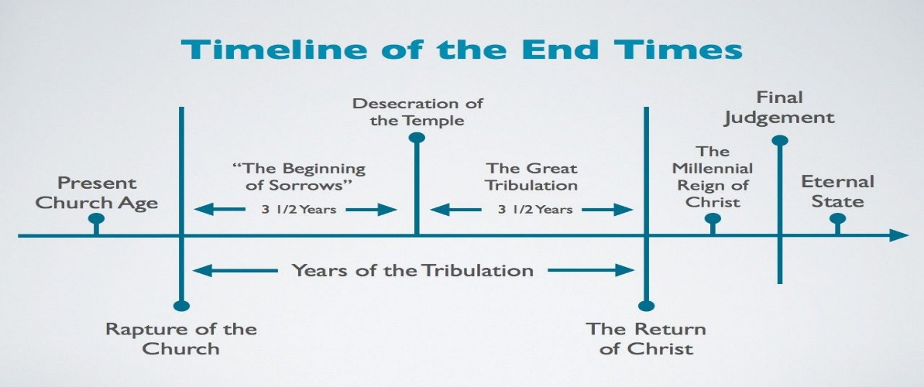
  - Key Point: Paul is informing Timothy and subsequently the entire church that the final days before Christ will return are guaranteed to be bad, difficult and then He describes exactly what that will look like and characterizes the world as it will be so the Church will be fully prepared.
  - How is this possible? The world just before Jesus returns will be prosperous and will decline into being one where people are lovers of self, lovers of money, and lovers of pleasure. This kind of mass societal decline has only occurred in societies that are very prosperous.
    - Deuteronomy 8:13-14 and when your herds and flocks grow large and your silver and gold increase and all you have is multiplied, then your heart will become proud and you will forget the LORD your God, who brought you out of Egypt, out of the land of slavery.
  - Elon Musk is building the AI and robotic future that will drive deflation and super abundance He is quoted as saying the following about the future.
    - "With robotics and AI, this is really the path to abundance for all... the only way to do this is AI and robotics."
    - "There will be universal high income. There will be no shortage of goods or services."
    - "AI and robots are going to make so much stuff and provide so many services that they'll run out of things to do for humans."
    - AI will increase the global economy by 20% to 30%, or about $20 trillion to $30 trillion per year."
  - It is important to understand that Paul is not painting a gradually perfected planet where eventually everyone gets saved and as the Church, we somehow usher in the full expression of the Kingdom. The world will

gradually progress away from God until Jesus returns.
    - The apostle Paul is not focusing our attention on wars, or plagues, or earthquakes, he is focusing our attention on what the heart of humanity will be full of just before Jesus returns.
  - The prosperity of the last days is meant to set a trap for the human soul to weigh it down with the pleasures of this life and cause it to be corrupted and unfit for the return of Christ.

  - 2nd Thessalonians 2:9-12 The coming of the lawless one is by the activity of Satan with all power and false signs and wonders, and with all wicked deception for those who are perishing, because they refused to love the truth and so be saved. And for this reason God will send them strong delusion, that they should believe the lie, 12in order that judgment may come upon all who have disbelieved the truth and delighted in wickedness.
    - The world that will exist just before the rapture will, hate the truth, mock and reject the gospel, and delight in wickedness, and because that is how the world will be before Jesus returns God will send them into tribulation period, so they will be deceived and be judged accordingly.
    - First the people harden there heart to God and His grace, then they delight in full wickedness, then they are allowed to become fully deceived, then they will die in there sins.

- The state of humanity at the time of the End 2nd Timothy 3:2 “For people will be lovers of self, lovers of money, boastful, arrogant, slanderers, disobedient to parents, ungrateful, unholy,”
  - Greek philautoi for Lovers of self , or self-absorbed. The word for selfish in Greek ends in the plural “Oi” meaning that this will not be a sliver of the population but the vast majority of humanity.
    - Self-care has been replaced with self-love. God intended that love would be given away, at the time of the end which we are arriving towards rapidly, mankind will not care for others but only for themselves, turning inwards unsympathetic and unbothered by the needs of others.
    - The greatest and highest priority in the last of the last days generation will be themselves.
  - Lovers of money or material possessions. The last days generation just before Jesus returns for His church, will be in love with what they have and never satisfied, coveting others possessions to the degree that they will not be able to wait for a desired possession and will do anything to get them.
    - Do we see people unable to delay gratification or desired purchases? The average household debt in America alone as of summer of 2026 was $105,444.00 according to Experian data.
    - People will be spending all of their money on themselves and will lack common generosity.
  - Boastful is not the full translation and meaning for the word we see in Greek. The word isἀλαζόνες or alazones describes a people who will; due to pride, intentionally manipulate the truth to be whatever they need the facts to be, removing moral absolutes in order to replace them with a new relevant truth. This word implies that the boastful will fight against the truth vehemently, militaristically so that they can advance their own cause on the earth.
  - Arrogant, they will be intellectually snooty, puffed up due to their personal achievements of knowledge, and secure overly confident in their opinions.
  - The world before Jesus comes will be full of blasphemers in Greek, or abusive slanderous people. The type of speech that the Holy Spirit tells us will be present in the last days will be Crude, rude and vulgar speech and will be present throughout all of society. The blasphemy in this text is not the kind towards God but is the common language of all peoples on earth.
  - The world just before Jesus returns at the last of the last days will see children be disobedient to parents.
    - The word tells us that children will not submit or respond to sound discipline, teachable by parents. The original Greek word tells us that what was common will now be uncommon, as if to say, broken intentionally like chains being undone. Children will be raising themselves without oversite.
    - Parental rights to train and prepare our children are under attack and have been in the past few decades. This perversion of parental rights and the subsequent unteachable spirit of our youth is a direct fulfillment of the words of this scripture.
    - As Christians we love our children and discipline them for their maturity and growth. We have been given the sole responsibility to raise our children, we cannot abdicate this responsibility to any other institution, God will hold us accountable, therefore you do not need any other permission to lead.
  - Ungrateful or unthankful, thankfulness will be uncommon because the world just before Jesus returns according to the text of scripture will become entitled.
    - Entitlement will replace gratitude and will cancel out normal gratitude and appreciation for others. Entitlement is the feeling that someone owes you something that they do not. It is a belief that for base reasons we are inherently deserving of privileges or benefits we have not earned.
    - Entitlement leads to laziness; the bible tells us what happens to the lazy in Matthew 25:26
    - The Christian is thankful for every blessing from the Lord, they endure suffering, and work hard as unto the Lord. Ultimately the Christian knows that this world is not the final destination and they are thankful because the future has already been secured by Jesus overcoming at the cross.
  - Unholy: Intentional irreverence towards anything that is sacred, a loss of respect for those institutions, covenants and relationships that should be honored.

- 2nd Timothy 3:3 unloving, trucebreakers, malicious gossips, without self-control, brutal, haters of good,
  - Unloving is the Greek word astorgoi and is a removal of love and affection between family members namely husbands, wives, brothers, and sisters. Hardheartedness. It represents the breakdown of the family unit.
  - Trucebreakers is from the Greek aspondoi and is a removal of covenant or treaty. It would be used to describe the breaking of marriage covenants in divorce. Covenants won’t mean much in the last days.
    - Since the word is in the plural form it tells us that in the time just before Christ shall come for His Church divorce will be widespread.
    - This word also implies people will refuse to make peace, will break agreements, and will refuse to enter into a covenant, that means, people will no longer even desire marriage.
  - As Christians we must guard our family, if families break apart then our society will crumble. It’s time to renew our love for our spouses and our children, spending time in common fellowship enjoying life together.
  - Malicious gossipers: the original language is diaboloi where we get “devils” from. This means Paul through the Holy Spirit is telling the Church just before Jesus comes for His Bride to be aware that in the last days demons will be prevalent and they will be in part to blame for expansion of evil.
  - Without-self-control is the Greek word akrateis which means a removal of or loss of power in society. It will be greater than just on an individual level but instead the word represents societal chaos, systems of government, finance will be out of control and won’t work properly.
    - As the Church we must take into consideration the current state of affairs in govt. and financial systems in relation to this word. We are seeing the demise of earthly governments and financial institutions at a rapid pace. 13% of people in an ongoing pew research study say they trust the government. down from 77% in the 1950’s. People have become less trusting of anyone and everyone in any position of leadership or authority, some for reason and some for no good reason.
  - Brutal: Greek anēmeroi meaning the destruction of culture to a degree where people will become fierce, violent lacking common courtesy, control like in the times of the Colosseum, it describes a culture that will delight in brutality and violence making it widespread.
    - Genesis 6:11-12 Now the earth was corrupt in the sight of God, and full of violence. 12And God looked upon the earth and saw that it was corrupt; for all living creatures on the earth had corrupted their ways.
  - Haters of good: This word describes a society that will hate those who are good and that will champion and create a system of laws that promote that which is evil over that which is good.

- We are called to Stand Firm until the end.
  - Matthew 24:12-13 12Because of the multiplication of wickedness, the love of most will grow cold. 13But the one who perseveres to the end will be saved. (escape the trap)
    - It is important that you guard your own heart from the love of self, love of money and the love of pleasure that is enveloping the world. Keep a pure heart of love for God and service to others.
  - Sometimes it can be hard to stay positive, to keep a good attitude because as Christians, we may find ourselves in situations, that zap our faith and wear us down.
  - The overcomer must find the strength that comes from waiting on the Lord, daily. Many are in the habit of meeting with God once a week or twice, but we will have to practice his presence daily to overcome.
  - To stand firm we must persevere, we have to grow to full maturity, no one should be coasting spiritually, the waters ahead are going to be difficult but not in a way that people may be thinking.
  - James 1:2- 4 2Consider it pure joy, my brothers, when you encounter trials of many kinds, 3because you know that the testing of your faith develops perseverance. 4Allow perseverance to finish its work, so that you may be mature and complete, not lacking anything.

